1. Write a map reduce program to join the below given two datasets using Reducer side join.

**DRIVER CLASS:**

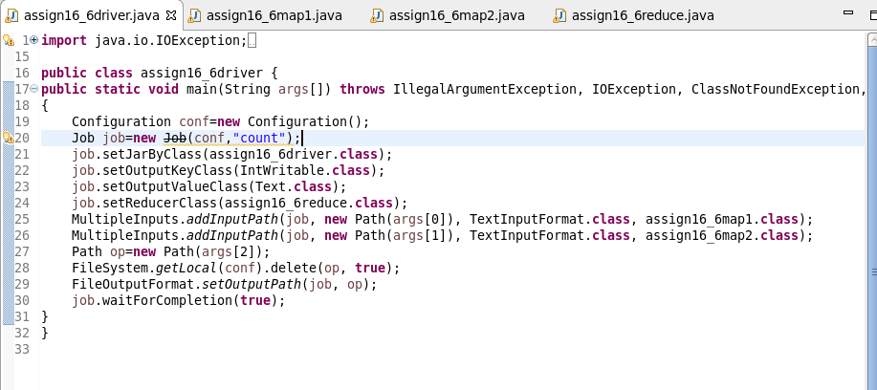

**MAPPER 1 CLASS:**

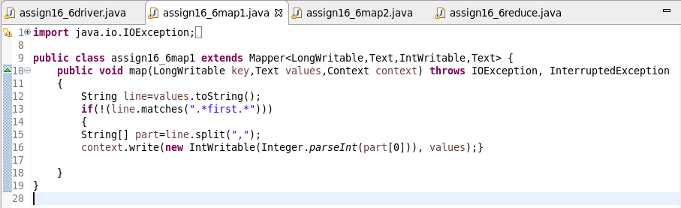

**MAPPER 2 CLASS:**

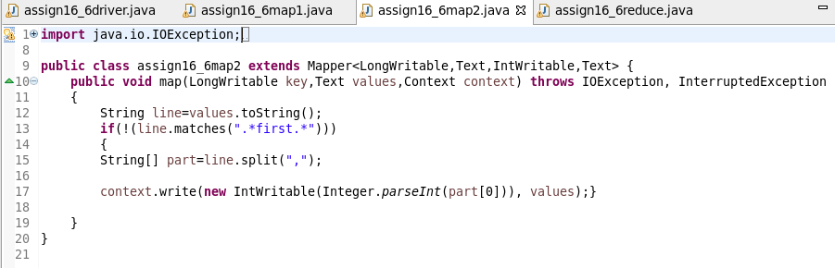

**REDUCER CLASS:**

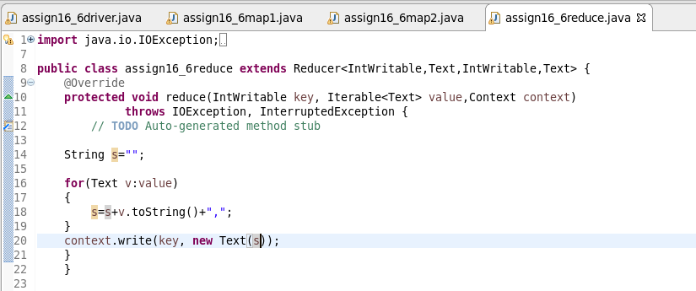

**RUNNING JAR:**

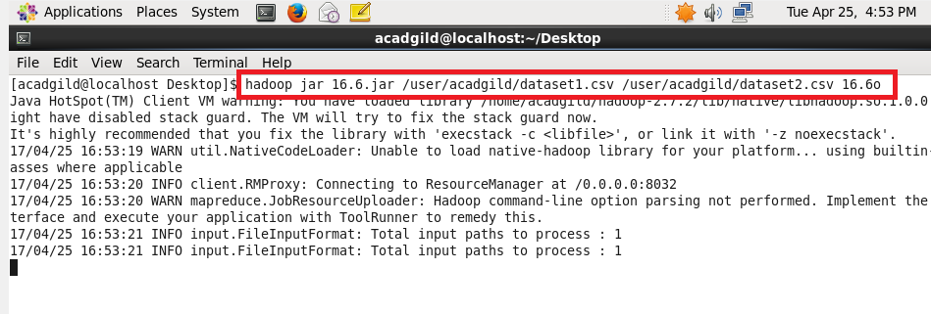

**OUTPUT:**

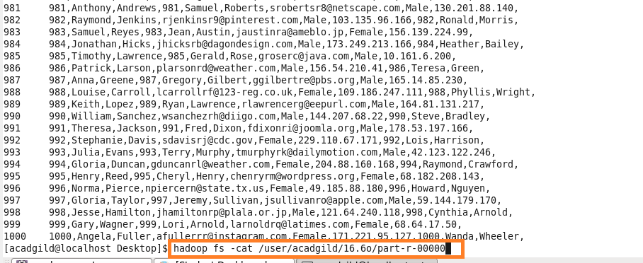

Thus the two datasets are joined using reduce side join.